AGRONOMY RESEARCH PROJECT REPORT
Date: 21st December 2014

Rhizoflo Premium in Potato Effects on yield and quality

Daniel O. Caldiz
Director Global de Agronomía, Investigación y Desarrollo, McCain Foods Limited. Ruta 226 km 61,500 B7620 Balcarce, Argentina. E-mail: dcaldiz@mccain.com.ar

 |  |  |  |  | General Information
 | Project Leader | Daniel Caldiz
 | Project Title | Effect of biological plant growth promoters on tuber yield and quality
 | Start Date | Start: October 2012
 | Completion Date | Completion: April 2015
 | Region and
 | Country | LATAM- Argentina
 |  |  |  |  |  |  |  | SCA | BGMPA | BGDG | OAGO
 |  |  |  | 1. | Varieties
 | Category and | 2. |  |  | Crop Production
 | Category and |  |  | 3. | Storage
 | Business Impact |  |  | 3. | Storage
 | Business Impact | 4. |  |  | CSR |  |  | X |  | X
 |  |  |  | 5. | Capability Building
 |  | 6. |  |  | ISC-Related Efforts

Executive Summary

Potatoes are a very high demanding crop regarding water and nutrients. Biological plant growth promotors (BPGP) are commonly used in soybean to improve N-uptake and in corn and wheat to improve root growth and P-solubilization. Results of two experiments carried out in the Villa Dolores region, Argentina, with Rhizoflo (Azospirillum spp. + Pseudomonas spp.), a BPGP not normally used in potatoes, are reported. During the 2013 experiments (late crop) significant yield increments were achieve in cv. Innovator, but not in cv. Spunta. However, during the 2014 experiments, significant yield increments were achieved in both varieties at the higher Rhizoflo rates, and also a significant reduction in the level of defects was achieved. These results also confirmed those obtained in the Balcarce region, Argentina during 2012/2013: Then, based on the results of these 3-year experiments it is proposed to implement the commercial use of Rhizoflo in potatoes.

Introduction

Potatoes are a high demanding resource crop. Water and nutrients should be applied to achieve high yields, under most environments. However, both resources impact on the crop carbon footprint. Both water and N fertilization have been recently identified as major contributors of the carbon footprint in processing crops (Haverkort and Walsh, 2011).

BPGP such as several species of Azospirillum spp., Pseudomonas spp. and Bacillus spp. are being commercially applied to improve crop performance in cereals and leguminous crops.
The advantage in the use of these BPGP is that they could improve nutrient and water use efficiency, either by improving nutrient availability or root growth or both. Hence, nutrient and water use efficiency could be improved and the carbon footprint of the crop could be reduced. There are also possible beneficial effects upon tuber quality due the impact of these beneficial microorganisms over pathogenic ones (A Kocmur, 2013, personal communication).

Results of the first trial, performed in Balcarce, Argentina, showed that Rhizoflo applied at planting (1.3 l ha⁻¹) increased tuber yield by 9%, and also significantly decreased the percentage of <50 mm tubers and the percentage of total tuber defects (Caldiz et al., 2013). Then, it was assumed that if Rhizoflo performed well in nutrient-rich soils (soil organic matter >5%), the effect should be higher in poor soil areas. Then, the aim of this second set of trials with Rhizoflo was to assess their effect on tuber yield and quality at field level, when applied to the seed tubers at planting time at different rates in a sandy soil region (soil organic matter < 2%).

Materials and Methods

Villa Dolores, Córdoba, Argentina, 2013

During the late crop (March-July) two field trials were planted with a 4-row planter on 12th March in replicated and randomized macro plots of 4 rows (x 0.85 m) of 120 m long with 3 replications of the cvs. Spunta and Innovator (5 seed pieces lineal m⁻¹). The crop was fertilized with 150 Kg ha⁻¹ Yara Nitro at planting and with 400 kg ha⁻¹ of Yara Nitrocomplex at hilling (14th April). Irrigation was carried out by furrow, and weeds, pests and diseases were controlled as normally done in the area. At planting time, Rhizoflo was applied with the planter mounted sprayer at a rate of 2.4 l ha⁻¹ with a water volume of 60 l ha⁻¹. At harvest, which was performed on 24th July 2013, 4 samples of 3 lineal meters per replication were manually collected.

Villa Dolores, Córdoba, Argentina, 2014

During the medium-early crop (August-December) two field trials were planted with a 4-row planter on 13th August in macro plots of 8 rows (x 0.85 m) of 120 m long (no replications) of the cvs. Spunta and Innovator (6 seed pieces lineal m⁻¹). The crop was fertilized with 250 Kg ha⁻¹ Yara Sulfan at planting. Irrigation was carried out by furrow, and weeds, pests and diseases were controlled as normally done in the area. At planting time, Rhizoflo was applied in each macroplot with the planter mounted sprayer with a water volume of 60 l ha⁻¹ as follows: a control, without treatment and at rates of 1.2; 2.4 and 3.6 l ha⁻¹. During the crop, emergence percentage at 30 days after planting (DAP) and stem number m⁻² was assessed at two different dates, while ground cover (GC) was periodically assessed following the procedure described by Caldiz et al. (1999) and it was used to derived ground cover duration (GCD). At harvest, which was performed on 1st December 2014, 10 samples of 3 lineal meters per each macroplot was manually collected.

In both trials, tuber samples were processed by a certified laboratorists (Receiving Area, QA Department, Argentina SA) as follows, for cv. Innovator. Each sample was weighed and tubers were graded in sizes: <50 mm, >50, >75 and > 90 mm. Dry matter percentage were measured. Individual and total tubers defects were measured following the McCain receiving Lab protocols.
For cv. Spunta, tubers were graded similar to cv. Innovator in 2013, while in 2014 tubers were graded in <75 and >75mm; dry matter and tubers defects were assessed as already described while fry color was not assessed.

For the 2013 trials results were statistically analyzed by an ANOVA and average values were compared using the LSD test at P <0.10 with the SAS program. For the 2014 trial results were analyzed by simply average comparison.

Results and Discussions

Emergence and Ground Cover

In 2013, an initial and positive effect on ground cover (visual assessment) in cv. Spunta did not reflect that early difference in final tuber yield (Fig. 1 and Table 1).

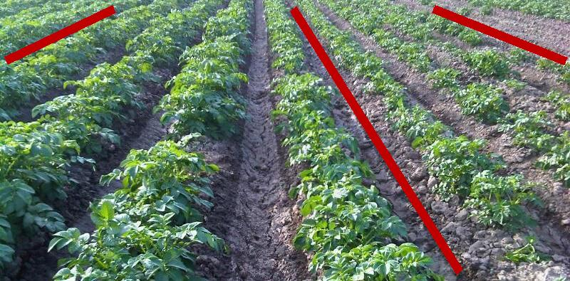

4 rows - Rhizoflo |  | 4 rows – Control

Fig. 1. Visual aspect of the Rhizoflo and control treatments in cv. Spunta, Villa Dolores, 2013.

In 2014, and for both cultivars, no differences in crop emergence were observed between treatments by 30 DAP (data not shown). However, the stem number m⁻² differed between the control and the Rhizoflo treatments in cv. Spunta, at both evaluation dates (Fig 2).
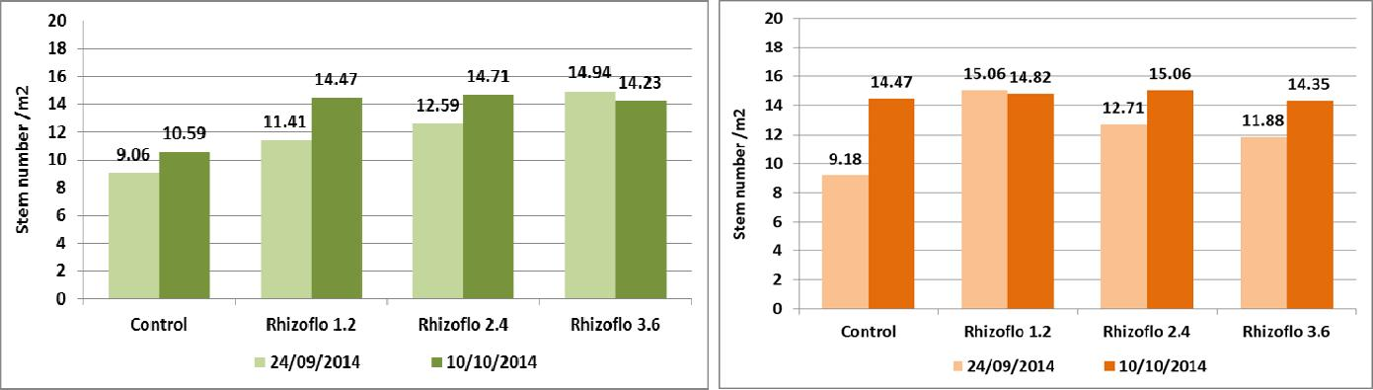

Fig. 2. Stem number m⁻² in cv.Spunta (left) and Innovator (right), Villa Dolores, 2014.

In cv. Innovator differences in the stem number were registered in the first assessment date, but not in the second one (Fig. 2). In both cases the stem number m⁻² were not correlated to the final tuber yield (data not shown).

However, ground cover (GC) evolution, in both cultivars, differed between treatments In cv. Spunta, differences in ground cover between the control and the Rhizoflo treatments were registered up to the 30th October, GC being higher in the treatments than in the control. In cv. Innovator differences in GC between the control and the Rhizoflo treatments were observed until 17th November (Fig. 4). Moreover, in both cases the GCD was related to final tuber yield (Fig. 10 and 11).

Tuber Yield and Quality

In the 2013 trial, in cv. Spunta, yield was not significantly modified by the Rhizoflo treatment, but the DM% was significantly increased and total tubers defects was significantly decreased (Table 1). In cv. Innovator, the Rhizoflo treatment significantly increased yield, but the DM% and the percentage of tubers defects were not modified by the treatment (Table 1).

Table 1. Yield and quality in cvs. Spunta and Innovator, late crop, Villa Dolores, 2013.
Treatment | Yield | DM | T. Defects | Size distribution (mm in %)
 | (ton ha⁻¹) | (%) | (%) | <50 | >50 | >75 | >90
Cv. Spunta
Control | 28.68 a | 19.57 b | 12.46 a | 5.02 a | 98.00 a | 97.23 a | 86.67 a
Rhizoflo 2.4 | 29.20 a | 20.35 a | 5.14 a | 8.04 b | 98.60 a | 93.44 a | 72.88 a
Cv. Innovator
Control | 18.66 b | 22.51 a | 1.20 a | 12.51 a | 88.00 a | 85.54 a | 55.00 a
Rhizoflo 2.4 | 20.69 a | 22.62 a | 2.13 a | 13.26 a | 87.00 a | 81.09 a | 53.24 a

Note: For each cultivar, figures on the same column followed by the same letter do not differ between them (α: 0.1). Yield and quality analysis were performed as described in de Lasa et al. (2012).

However, in the 2014 trial, yield was increased in both cultivars, mainly in the 2.4 and 3.6 lt ha⁻¹ rates. In cv. Spunta also the DM% was increased in these two rates, while also tubers total defects were dramatically reduced, mainly in the 3.6 l ha⁻¹ rate (Fig. 5, 6 and 7).

In the case of cv. Innovator, yield was also increased by the Rhizoflo treatment, mainly by the 3.6 l ha-1 rate. In this cultivar the DM%, which was already high for this cultivar and environment, was not modified by the treatments. However, as it was the case in cv. Spunta, total defects were much lower in the Rhizoflo treatments, when compared to the control (Fig. 9 and 10).

Moreover, in both cultivars, yield was associated to GCD, as already shown for potatoes grown under different situations (Fig. 8 and 11)

Fig. 5. Tuber yield in cv. Spunta, Villa Dolores, 2014.

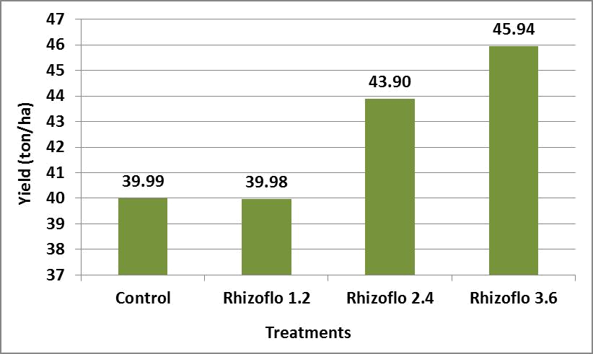

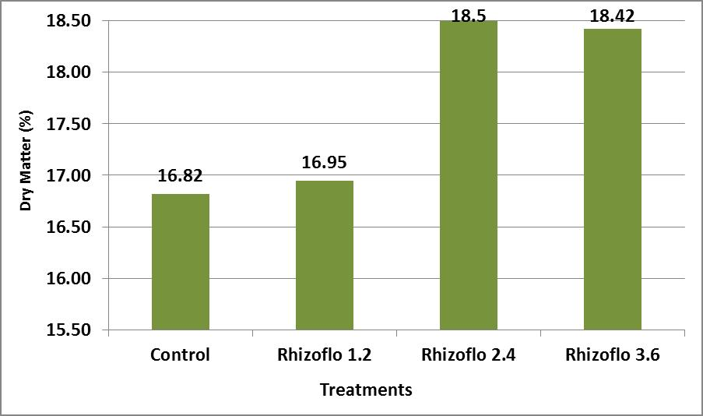

Fig. 6. Dry matter percentage in cv. Spunta, Villa Dolores, 2014.

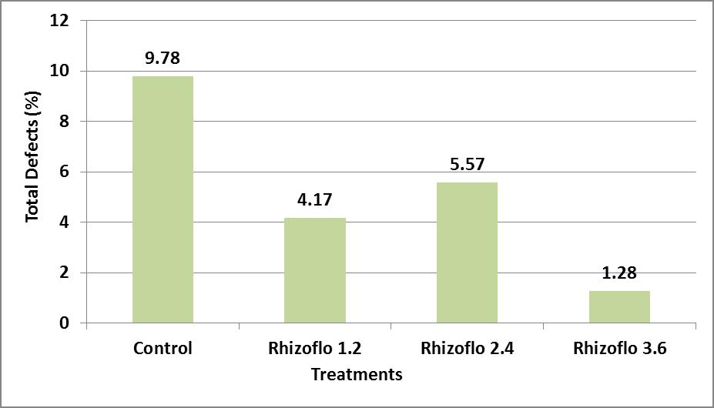

Fig. 7. Total defect percentage in cv. Spunta, Villa Dolores, 2014.

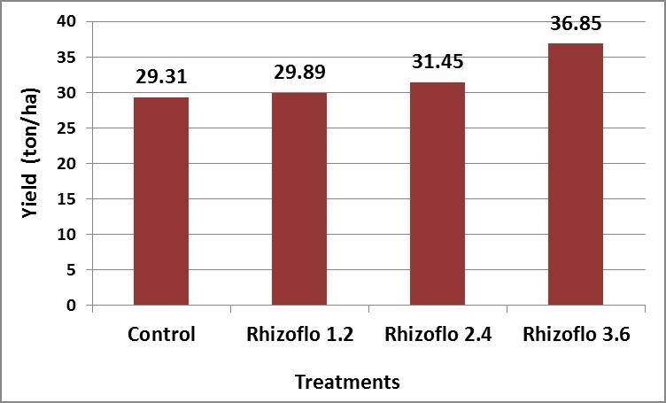

Fig. 9. Tuber yield in cv. Innovator, Villa Dolores, 2014.

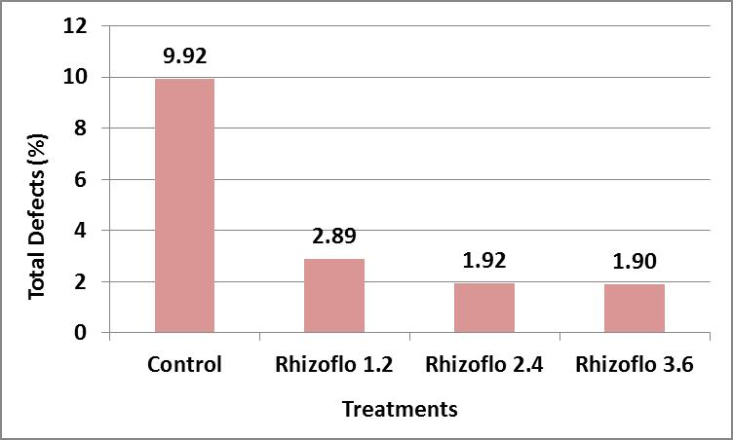

Fig. 10. Total defects percentage in cv. Innovator, Villa Dolores, 2014

Conclusions and Recommendations

The treatments with Rhizoflo, a biological plant growth promotor (Azospirillum spp. + Pseudomonas spp.) improved tuber yield and dry matter percentage while decreased total tubers defects when applied at planting time at rates of 1.3 and 3.6 l ha⁻¹ in nutrient-rich and sandy soils, respectively.

- Yield was increased in average by >11% when treatments results of the trials performed in the Southeast region (2012/2013) and in Villa Dolores (2013 and 2014) where compared. For the Villa Dolores region the higher rate treatments applied in 2014 were used.

- Dry matter percentage was only increased in cv. Spunta (2013 and 2014), while no effects upon cv. Innovator was observed.

- Total tubers defects, an important quality variable, either for potatoes to be delivered to the market or the processing industry where reduced in average by >62%

Then, based on the results of these 3-year trials it is recommended to commercially applied Rhizoflo in processing crops, at rates of 1.3-1.5 l ha⁻¹ in nutrient-rich soils (>4% OM) and at higher rates, of 3.6 l ha⁻¹ in sandy soils (<2% OM).

Daniel O. Caldiz, Ph D
Director Global de Agronomía R&D
McCain Foods Limited, Balcarce

